**Computer Vision Assignment - 1**

IIT2014068 | Prateek Agarwal

**Q1. In how many lobes a brain structure can be categorized?**

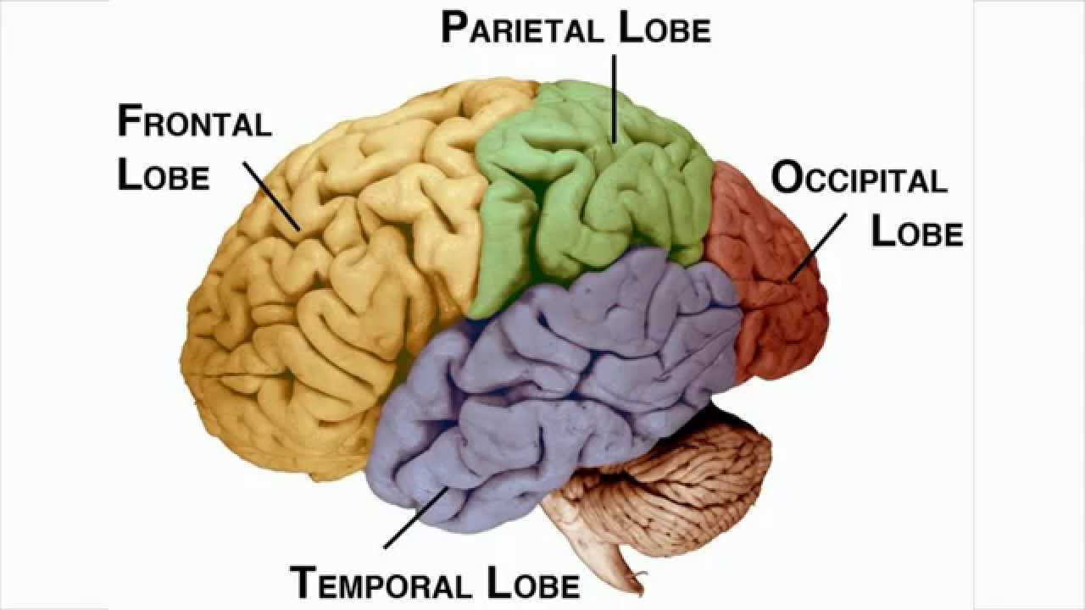

**Ans.** The Human Brain is broadly categorized into 4 lobes namely :

* Frontal Lobe : Reasoning and Logic
* Parietal Lobe : Movement / Static Map of the Body
* Occipital Lobe : Vision
* Temporal Lobe : Attention / Memory

The cerebellum can be subdivided into the following **3** lobes - anterior, posterior and flocculonodular lobes.

**Q2. What is gyrus and sulcus?**

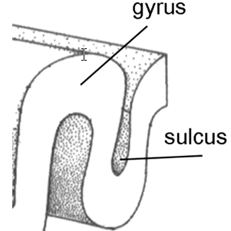

**Ans.** Clearly, the Gyrus is a ridge, or more informally a ‘bump’. It is surrounded by one more or Sulcus which is a depression or a groove which is surrounded by one or more gyrus. Together they help in increasing the total surface area of the brain. Infact ⅔ of the surface area of the brain is hidden in the grooves. We require them due to the limited size of the skull the human body has. Thus in order to increase the amount of matter (neurons) in the brain, evolution proceeded to increase the total surface area by developing gyri and sulci.

**Q3. Mention analogy between eye and camera (in tabular form)?**

|  |  |  |
| --- | --- | --- |
| **Analogies** | **Camera** | **Eye** |
| Functionality | The function of the camera is also to capture the world and provide vision. The camera can be used to for the same purpose as a human eye but it can also take images of other wavelengths such as infrared, x-rays, ultraviolet and so on. | The function of the eye is to capture the world and provide vision. The image of the surroundings captured is used to react, create, plan, move and so on |
| Entry point | The eye has the pupil as the entry point for the eye. All rays must enter through the pupils to form an image on the retina. | The camera has the frontal lens (aperture) as the entry point. All rays must enter through this lens to form an image on the film. |
| Nature of Image | The camera has the film as the screen on which the rays form an image. The image formed is also inverted in nature. | The eye has the retina as the screen on which the light rays form an image. The image formed is inverted in nature. |
| Control intake of light | The diaphragm is used to control the intake of light. The diaphragms machinery controls the intake of light. | The iris is used to control the intake of light. The iris contracts to increase the intake of light and relaxes to reduce the intake of light. |
| Lens | In a camera, the focusing screw allows the user to adjust the focus for nearer or more distant objects. In smarter cameras the process is automated on the basis of the clarity of the current image formed on the film. | In the human eye, ciliary muscles stretch or slacken the suspensory ligaments to adjust the shape of the lens. |
| Prevent reflection | The interior of the camera is coated with paint in order to fulfill the same purpose. | The choroid is dark film surrounding the eye which limits uncontrolled reflection in the eye in order to form a clear image. |
| Conversion of energy | The camera converts light energy to electrical (nowadays in digital) or photochemical form (on film). | The eye converts light energy to electrical energy (impulses) sent to the brain. |

**Q4. What are photoreceptors and where are they located?**

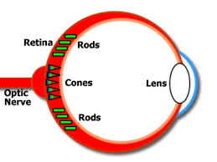

**Ans.** Photoreceptors are cells which are actually a specialized form of a neuron. They are capable of phototransduction which is the process by which light is converted into electrical impulses which are sent to other photoreceptors cell and eventually to the optic nerve, where all such impulses are aggregated and sent to the form. These impulses, create the vision of the world which we see.

There are three kinds (although the former 2 are most important) of photoreceptors in the eye each of which contributes information to provide sight :

1) **Rods** - Located mostly in the outer regions of the retina, the region faraway from the fovea centralis which is located almost right behind the lens. It is the region of highest visual accuracy. They are very sensitive to light and are useful in providing peripheral and night vision.

2) **Cones** - Concentrated in the fovea centralis and are activated only after a certain threshold of light intensity is incident on them. They provide us with color vision and sharp images.

3) Intrinsically photosensitive retinal ganglion cells.

**Q5. Write short description (1-3 sentence) on:**

**Ans.**

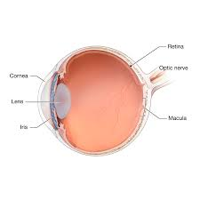

**1. Iris :** The iris is a part of the front region of the eye. It is thin and circular in shape. It is responsible for controlling the diameter and size of pupil to control the intake of light. It also defines the colour of the eye.

**2. Pupil :** The pupil is a hole which acts as an entry point for the light to enter the eye. It is located in the center of the iris. It appears black because all the light which enters is absorbed by the tissues inside the eye.

**3. Lens :** The lens refracts the light rays entering the eyes in a way so as to form the image on the retina of the eye. The ciliary muscles contract and relax to change the shape of the lens in order to form a clear image. The lens is biconvex and transparent.

**4. Retina :** The retina acts as the screen on which the image of the world is formed. It contains photoreceptors which convert the light into electric impulses to be sent to the brain, thus beginning the process of sight.

**Q6. Write short description (1-3 sentence) on:**

**Ans.** All below descriptions are based on anatomical locations in the body (so its general and not only applicable to the brain. The meaning remains the same for all organs)

1. **Superior** is usually used to describe an object which is above another object. Thus, the more above an object is in the body, the more superior it is.

2. **Middle** as an anatomical position can be used in various contexts, although it is usually used with superior and inferior. E.g Superior, middle and inferior part of brain. Its meaning is literal.

3. **Inferior** is usually used to describe an object which is below another object. Thus, the more below an object is in the body, the more inferior it is.

4.The **dorsal** surface of an organism is used to refer to the back or upper side of the organism (in quad legged animals). In humans dorsal means back.

5.The **ventral** surface of an organism is used to refer to the front or lower side of the organism (in quad legged animals). In humans ventral means front.

**Q7. What kind of information is processed in low level, intermediate level and high level vision?**

**Ans.** In low-level vision information related to pre-processing tasks is usually handled. This includes image filtering, isolated feature detection and consistency calculations. Intermediate-level vision deals with information regarding segmentation, selection of features and calculation of invariants.High-level vision includes processes information regarding stereo vision, color and motion perception, object recognition of complete and incomplete objects and so on.

**Q8. What is lateral geniculostriate pathway?**

**Ans.** The lateral geniculo striate pathway is one of three important visual pathways. The pathway gets its name from the lateral geniculo striate nucleus (LGN) which connects the optic fibre to the occipital lobe. The LGN acts as a relay center as well as a controller and is located in the thalamus of the brain. It also receives strong feedback signals from the primary visual cortex. The LGN receives inhibitory, excitatory or modulatory signals from the optic fibre which it then sends to the occipital lobe for processing. It performs a lot many anatomical calculations. These include temporal and spatial correlations/de-correlations. Some of its functions are -

1)Control the direction of the eye in order to focus on the object.

2)Control the shape of the lens so as to form a sharp image of the focused object.

3)Determining the relative position and velocity of objects in the view volume of the eye.

**Q9. What is the role of following (in 1-3 sentences):**

**1. Ciliary Muscles :** The ciliary muscles control the shape of the lens. By changing the shape of the biconvex lens the incident rays are made to form a sharp image on the retina.

**2. SC :** The superior colliculus (SC) plays a major role in integrating various sensory information (visual, auditory, somatic) in order to move the head and orientation of eyes towards the stimuli.

**3. Pretectum :** The pretectum is located in the midbrain. It mediates behavioral responses to sudden changes in ambient light, such as controlling pupillary reflexes and so on.

**4. FEF :** The role of the frontal eye fields is to control voluntary eye movements and it is also responsible for visual field perception and awareness.

**Q10. What is the pathway to make saccade movements of eye? (write name of the brain organs only)**

**Ans.** The pathway taken to make saccade movements of the eye are :

1. Eyes
2. Lateral Geniculo Striate Nucleus
3. Superior Colliculus
4. Primary Visual Cortex
5. Posterior Parietal Cortex
6. Frontal Eye Fields
7. Caudate Nucleus
8. Substantia Nigra
9. Paramedian/Mesencephalic Pontine -Reticular Formation
10. Abducens Nucleus
11. Abducens Nerve